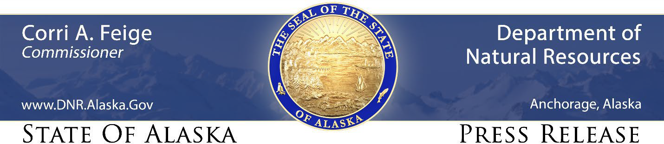

For Immediate Release: June 4, 2021

Nominations sought for 2021 Alaska Farm Family of the Year

(Palmer, AK) – The Division of Agriculture and the Alaska State Fair invite the public to submit nominations for the twenty-second annual “Farm Family of the Year” award, to be presented at the 2021 Alaska State Fair.

The “Farm Family of the Year” award was established in 2000 by the Division of Agriculture and the Alaska State Fair with the intent to honor an Alaska farm family that best epitomizes the spirit of the agriculture industry for the year, and to show appreciation for hard-working Alaskans committed to agriculture and mariculture.

The 2020 winning family was the Bates of Halibut Cove, Alaska. Previous winners include the St Pierres of Ester, the Olsons of Soldotna, and the McCollums and Pinklemans of Delta Junction.

Nominations will be accepted through July 15, and can be submitted at https://www.surveymonkey.com/r/2021FFY.

Throughout the nomination period, the “Alaska Grown” Facebook page (https://www.facebook.com/dnr.alaskagrown/) will feature nominated farm families from across the state, with information on their history and influence on Alaska agriculture.

CONTACT: Glenda Grawe, (907) 795-9700, glenda.grawe@alaska.gov

###

STAY CONNECTED:
DNR Newsroom: http://dnr.alaska.gov/commis/dnr_newsroom.htm
DNR on Social Media: http://dnr.alaska.gov/commis/social_media.htm
DNR Public Information Center: http://dnr.alaska.gov/commis/pic/

